DDL

CREATE: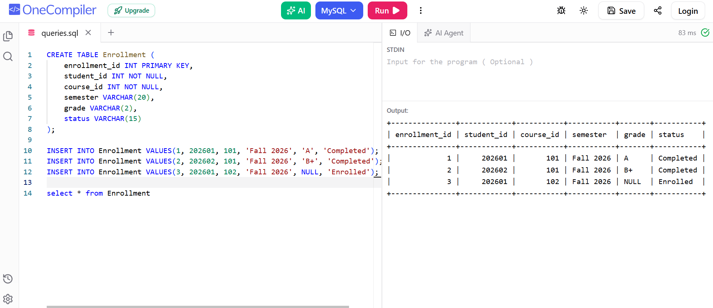

ALTER:
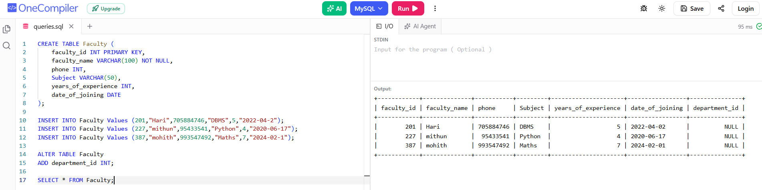
DROP:
